PROTOCOL
2nd World Olympics, World Championship, 2nd Open South America Championship, 2nd Open Ecuador Championship, International Tournament in honour of Simeon Bolivar on Kettlebell Triathlon under the extreme conditions of highland on Chimborazo Volcano, the world’s highest mountain (if measured from the Earth center up to the peak)
Height 4,800 m
South America, Ecuador, Chimborazo Volcano 27 February 2014
Name | Country | Date of Birth | Weight | Weight class | Result | Place | Record
MEN
Kettlebell jerk (16 kg) with one-time interception, Time-limit 1 min.
Weight class under 55 kg.
1. Alexander Iofinov | Belarus | 1940 | 54.9 | 55 | 54 | 1 | OR, WR
2. Diego Dorado | Argentina | 1989 | 54.6 | 55 | 49 | 2 | –
3. Juanito Veres | Peru | 1993 | 54.5 | 55 | 41 | 3 | –
Weight class under 60 kg
1. Oleg Lisitsyn | Russia | 1953 | 59,5 | 60 | 58 | 1 | OR, WR
2. Luis Reyes | Ecuador | 1985 | 59,8 | 60 | 41 | 2 | –
3. Jack Puri | Panama | 1995 | 59,7 | 60 | 40 | 3 | –
Weight class under 65 kg
1. Valery Veretennikov | Russia | 1952 | 64,7 | 65 | 64 | 1 | OR, WR
2. Albert Maso | Venezuela | 1979 | 64,9 | 65 | 57 | 2 | –
2. Mar Botizha | Bolivia | 1991 | 63,5 | 65 | 51 | 3 | –
3. Fernando Alenso | Colombia | 1989 | 64,1 | 65 | 43 | 4 | –
Weight class under 70 kg
1. Alexander Ezhov | Russia | 1982 | 69,6 | 70 | 67 | 1 | OR, WR
2. Lavreas Pancho | Mexico | 1987 | 68,9 | 70 | 59 | 2 | –
3. Manuel Rivaz | Brazil | 1971 | 67,7 | 70 | 53 | 3 | –
Weight class under 75 kg
1. Vladimir Katashuk | Belarus | 1956 | 73,2 | 75 | 52 | 1 | OR, WR
2. Alex Lomas | Ecuador | 1978 | 71,9 | 75 | 51 | 2 | –
3. Raymon Masalles | Chile | 1987 | 74,5 | 75 | 45 | 3 | –
Weight class under 80 kg
1. Nickolay Sungurov | Russia | 1957 | 76,1 | 80 | 37 | 1 | OR, WR
2. Adolfo De Bosta | Paraguay | 1969 | 79,1 | 80 | 35 | 2 | –
3. Victor Revilla | Uruguay | 1994 | 78,9 | 80 | 31 | 3 | –
Weight class under 85 kg
1. Nickolay Levchenko | Ukraine | 1949 | 83,4 | 85 | 52 | 1 | OR, WR
2. Urbino Morallez | Cuba | 1991 | 84,9 | 85 | 49 | 2 | –
3. Alberto Gugo | Portuguese | 1987 | 84,9 | 85 | 19 | 3 | –
4. Mouricio Sanchez | Spain | 1985 | 82,5 | 85 | 41 | 4 | –
Weight class under 90 kg
1. Victor Sayko | Kazakhstan | 1955 | 88,8 | 90 | 59 | 1 | OR, WR
2. John West | USA | 1989 | 89,9 | 90 | 55 | 2 | –
3. Emanuel Gulyen | Guiana | 1990 | 87,7 | 90 | 53 | 3 | –
4. Quinta Pedro | Surinam | 1994 | 85,5 | 90 | 41 | 4 | –
5. Jacques Fisher | Canada | 1985 | 88,8 | 90 | 37 | 5 | –
Weight class under 95 kg
1. Andrey Lisitsyn | Russia | 1994 | 91,1 | 95 | 71 | 1 | OR, WR
2. Emanuel Gugo | Colombia | 1992 | 94,5 | 95 | 51 | 2 | –
3. Miguel Ignasio | Peru | 1979 | 93,7 | 95 | 43 | 3 | –
Weight class under 100 kg
1. Mansuro Uerto | Chile | 1987 | 99,3 | 100 | 60 | 1 | OR, WR
Weight class under 105 kg
1. Miguel Solaras | Argentina | 1983 | 104,6 | 105 | 63 | 1 | OR, WR
Weight class under 110 kg
1. Anatoly Ezhov | Russia | 1946 | 107,3 | 110 | 92 | 1 | OR, WR
2. Allen Svidler | USA | 1949 | 109,9 | 110 | 51 | 2 | –
3. Ignasio Rodrigez-Vorlado | Brazil | 1987 | 107,7 | 110 | 50 | 3 | –
4. Andres Fernandez | Uruguay | 1977 | 106,3 | 110 | 49 | 4 | –
5. Serge Alkalle | Paraguay | 1993 | 108,9 | 110 | 47 | 5 | –
6. John Rodrigez | Panama | 1995 | 105,9 | 110 | 45 | 6 | –
7. Ivan Lorente | Bolivia | 1987 | 106,1 | 110 | 44 | 7 | –
Weight class + 110 kg
1. Vladimir Sadakov | Russia | 1967 | 112,2 | +110 | 74 | 1 | OR, WR
2. Kevin White | Canada | 1986 | 127,0 | +110 | 55 | 2 | –
3. Velares Choku | Mexico | 1991 | 131,2 | +110 | 52 | 3 | –
4. Manuel Rojiero | Chile | 1987 | 115,3 | +110 | 51 | 4 | –
5. Serafim Gonzalez | Venesuela | 1991 | 111,0 | +110 | 47 | 5 | –
The overall winner in jerk (16 kg) in 1 minute with the score 92 lifts is Anatoly Ezhov (Belarus)

MEN
Long cycle (16 kg) with one-time interception
Weight class under 65 kg
1. Valery Veretennikov | Russia | 1952 | 64,7 | 65 | 28 | 1 | OR, WR
WOMEN
Kettlebell jerk (12 kg) with one-time interception. Time-limit 1 min.
Weight class under 60 kg
1. Marina Maslova | Union State | 1978 | 58,6 | 60 | 45 | 1 | OR, WR
2. Marta Perez | Colombia | 1985 | 59,9 | 60 | 33 | 2 | –
3. Karmelia Seten | Argentina | 1995 | 58,7 | 60 | 31 | 3 | –
Weight class under 75 kg
1. Nadezhda Agurto | Ecuador | 1958 | 74,5 | 75 | 38 | 1 | OR, WR
2. Felidia Moreno | Chile | 1978 | 72,1 | 75 | 31 | 2 | –
3. Barbara Alibes | Venezuela | 1989 | 73,7 | 75 | 27 | 3 | –
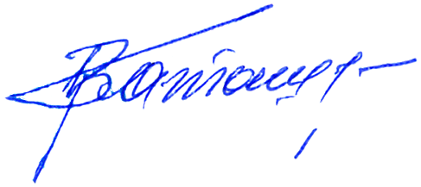Note: OR – Olympic record; WR – World record
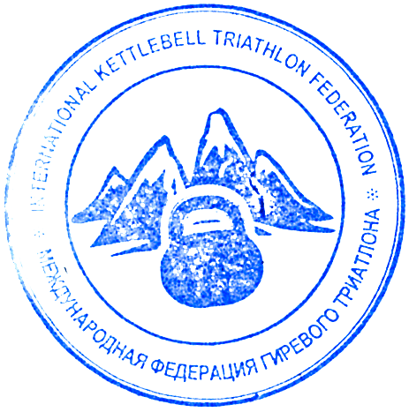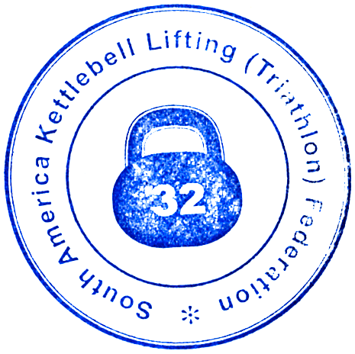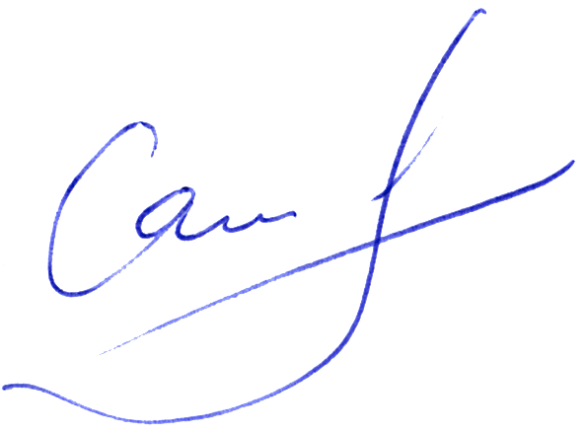
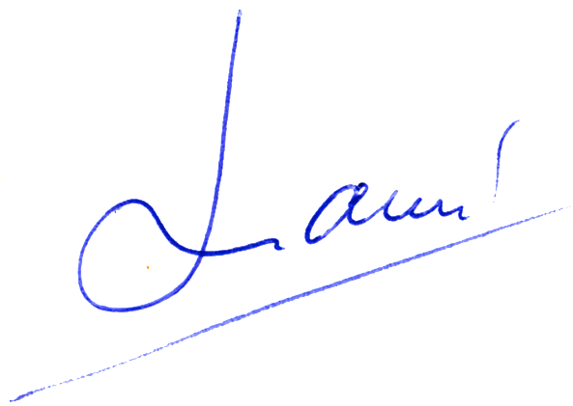Chief referee Vladimir Katashuk (Belarus)
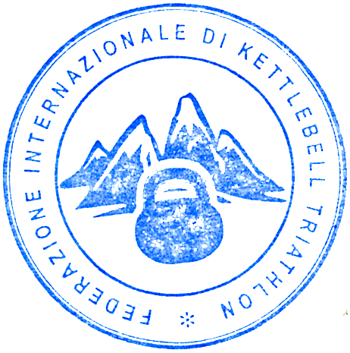Chief secretary Victor Sayko (Kazakhastan)
Chief platform referee Alex Lomas (Ecuador)

