PROTOCOL
2nd World Olympics, 2nd World Championship, 2nd Open South America Championship, 2nd Open Ecuador Championship, International Tournament in honour of Simeon Bolivar on Kettlebell Triathlon under the extreme conditions of highland on the Middle of the World, the equator line at the height of 2,483 meters, standing one foot in the Northern Hemisphere and another in the Southern Hemisphere
South America, Ecuador, the Middle of the World, the equator line, 26th km distance from Quito, the capital of Ecuador 1 March 2014
Name | Country | Date of Birth | Weight | Weight class | Result | Place | Record
MEN
Kettlebell jerk (16 kg) with one-time interception, Time-limit 1 min.

Weight class under 65 kg
1. Valery Veretennikov | Russia | 1952 | 64,7 | 65 | 70 | 1 | OR, WR
2. Lukas Calve | Argentina | 1987 | 64,7 | 65 | 58 | 2 | –
3. Fernando Alonso | Colombia | 1989 | 64,1 | 65 | 47 | 3 | –
Weight class under 75 kg
1. Vladimir Katashuk | Belarus | 1956 | 73,2 | 75 | 63 | 1 | OR, WR
2. Sichini Puyg Gido | Argentina | 1987 | 74,2 | 75 | 60 | 2 | –
3. Oscar Tavav | Chile | 1981 | 74,9 | 75 | 52 | 3 | –
Weight class under 80 kg
1. Nickolay Sungurov | Russia | 1957 | 76,1 | 80 | 61 | 1 | OR, WR
2. German Stel | Argentina | 1987 | 78,3 | 80 | 60 | 2 | –
3. Miguel Maurisio | Panama | 1991 | 79,9 | 80 | 52 | 3 | –
Weight class under 85 kg
1. Nickolay Levchenko | Ukraine | 1949 | 83,4 | 85 | 65 | 1 | OR, WR
2. Federiko Maranga | Argentina | 1986 | 80,7 | 85 | 55 | 2 | –
3. Urbino Morallez | Cuba | 1991 | 84,9 | 85 | 53 | 3 | –
Weight class under 90 kg
1. Victor Sayko | Kazakhstan | 1955 | 88,8 | 90 | 60 | 1 | OR, WR
2. Pini Markelo | Argentina | 1986 | 86,0 | 90 | 52 | 2 | –
3. Emanuel Julien | Guiana | 1990 | 87,7 | 90 | 51 | 3 | –
Weight class under 95 kg
1. Andrey Lisitsyn | Russia | 1994 | 91,1 | 95 | 67 | 1 | OR, WR
2. Emanuel Gugo | Colombia | 1992 | 94,5 | 95 | 53 | 2 | –
3. Miguel Ignasio | Peru | 1979 | 93,7 | 95 | 51 | 3 | –
Kettlebell snatch (16 kg) with one-time interception. Time-limit 1 min.
Weight class under 55 kg
1. Alexander Iofinov | Belarus | 1940 | 54.9 | 55 | 31 | 1 | OR, WR
2. Juanito Veres | Peru | 1993 | 54.5 | 55 | 23 | 2 | –
3. Diego Dorado | Argentina | 1989 | 54.6 | 55 | 21 | 3 | –
Weight class under 60 kg
1. Oleg Lisitsyn | Russia | 1953 | 59,5 | 60 | 34 | 1 | OR, WR
2. Jack Puri | Panama | 1995 | 59,7 | 60 | 25 | 2 | –
3. Luis Reyes | Ecuador | 1985 | 59,8 | 60 | 23 | 3 | –
Weight class under 65 kg
1. Valery Veretennikov | Russia | 1952 | 64,7 | 65 | 44 | 1 | OR, WR
2. Fernando Alenso | Colombia | 1989 | 64,1 | 65 | 25 | 2 | –
3. Mar Botizha | Bolivia | 1991 | 63,5 | 65 | 23 | 3 | –
Weight class under 80 kg
1. Nickolay Sungurov | Russia | 1957 | 76,1 | 80 | 30 | 1 | OR, WR
2. Victor Revilla | Uruguay | 1994 | 78,9 | 80 | 23 | 2 | –
3. Adolfo De Bosta | Paraguay | 1969 | 79,1 | 80 | 22 | 3 | –
Weight class under 85 kg
1. Nickolay Levchenko | Ukraine | 1949 | 83,4 | 85 | 36 | 1 | OR, WR
2. Alberto Gugo | Portuguese | 1979 | 84,3 | 85 | 27 | 2 | –
3. Urbino Morallez | Cuba | 1991 | 84,9 | 85 | 25 | 3 | –
Weight class under 110 kg
1. Anatoly Ezhov | Union State | 1946 | 107,3 | 110 | 47 | 1 | OR, WR
2. Chana Rodrigez | Panama | 1995 | 105,9 | 110 | 29 | 2 | –
3. Ivan Lorente | Bolivia | 1987 | 106,1 | 110 | 28 | 3 | –
WOMEN
Kettlebell jerk (12 kg) with one-time interception. Time-limit 1 min.
Weight class under 60 kg
1. Marina Maslova | Russia | 1978 | 58,6 | 60 | 43 | 1 | OR, WR
2. Valentina Pese Leon-Duran | Colombia | 1989 | 59,1 | 60 | 37 | 2 | –
3. Marta Petrosyan | Ecuador-Armenia | 1979 | 59,9 | 60 | 23 | 3 | –
Weight class under 75 kg
1. Nadezhda Agurto | Ecuador | 1958 | 74,5 | 75 | 39 | 1 | OR, WR
2. Liana Koronel | Argentina | 1990 | 71,0 | 75 | 24 | 2 | –
3. Barbara Alibes | Venezuela | 1989 | 73,7 | 75 | 23 | 3 | –
Kettlebell snatch (12 kg) with one-time interception. Time-limit 1 min.
Weight class under 60 kg
1. Marina Maslova | Russia | 1978 | 58,6 | 60 | 35 | 1 | OR, WR
2. Rono Machuchi | Ecuador | 1991 | 59,9 | 60 | 32 | 2 | –
3. Karmelia Seten | Argentina | 1995 | 58,7 | 60 | 25 | 3 | –
Note: OR – Olympic record; WR – World record
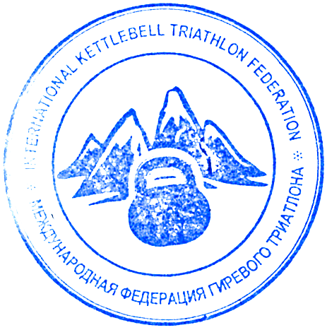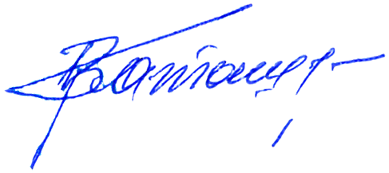The overall winner in jerk (16 kg) in 1 minute with the score 47 lifts is Anatoly Ezhov (Union State)

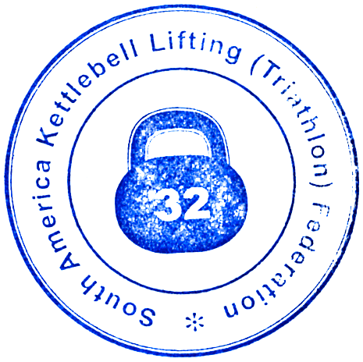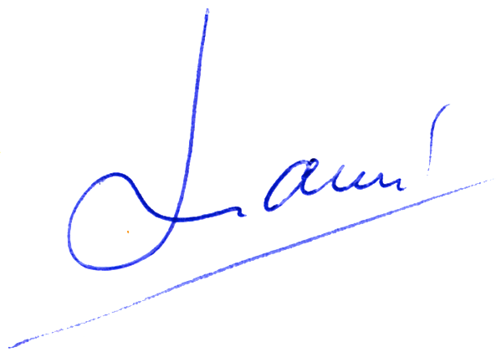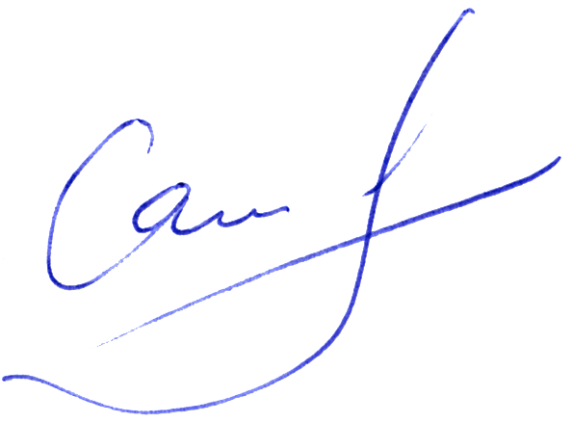Chief referee Vladimir Katashuk (Belarus)
Chief secretary Victor Sayko (Kazakhastan)
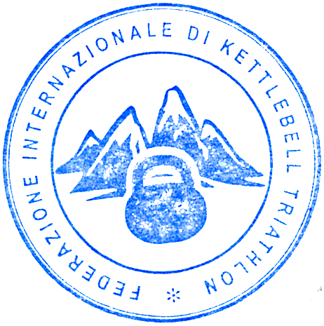Chief platform referee Alex Lomas (Ecuador)

